SPE Brazil Flow Assurance Technology Congress
Rio de Janeiro, Brazil, November 06 – 08 2024

Title in Arial 14, Bold

Author name and Surname¹, Author name and Surname ^{2*} (Arial 12)
(Example: Susan P. Smith¹, Paul Jones²)
¹Department/Institute of Research, University, Country (Arial, 10)
²Department/Institute of Research, University, Country, *email of corresponding author

Abstract (Arial 12, bold)
The abstract should be written in Arial, size 10, using justified format. Use short and concise sentences. The abstract should contain up to 200 words in a single paragraph.

Keywords (Arial 12, bold)
keyword 1; keyword 2; keyword 3 (up to 3 keywords, separated by semicolons) (Arial, 10)

Introduction (Arial 12, bold)
All sections must be written in English and the full contribution should contain between 2 and 4 pages.
The file to be submitted must be in pdf format. For the content of all sections, use Arial, 10, justified alignment and single space paragraph. Between paragraphs do not use any tabulation or space, only the <enter> key.
References should be inserted along the text along the order of its appearance, using the format [1].

Methodology (Arial 12, bold)
Insert here the section containing the description of the procedure for the research development (Arial 10).

Experimental Procedure (Arial 10)
In the case of subsections, insert the subtitle in bold.

Equations (Arial 10)
Equations must be written in Arial 10, using Arabic numerals in parentheses for identification. The equation should be referred to as “Eq. (1)” throughout sentences and as “Equation (1)” at the beginning of the sentence. Matrices and vectors can be indicated by braces or square brackets, as in Eq. (1).
Symbols used in equations should be explained immediately before or after they first appear in the text.

[M]{x(t)}+ [C]{x(t )}+ [K]{x(t)}= {f (t)} (1)

Results and Discussion (Arial 12, bold)
Insert the figures in an appropriate place, as close as possible to their citation in the text. “Fig. (1)” must be used in the middle of a sentence and “Figure 1” at the beginning of a sentence, leaving at least one blank line, size 10 pt, above and below each one.
The figure must be ordered in Arabic numerals, properly addressed in the text, with the legend below the image. If the caption is smaller than the column width, it must be centered (Arial 10).

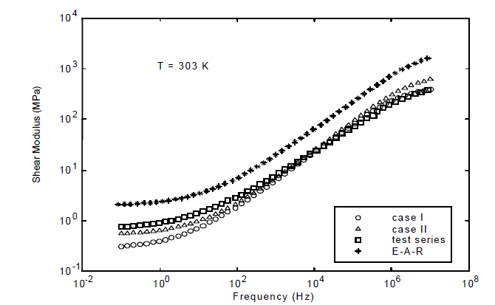
Figure 1. Insert the figure caption. (Arial 10)

Tables should also be ordered with Arabic numerals, as close as possible to their citation in the text. Reference should be made to “Tab. 1” if in the middle of a sentence or “Table 1” if at the beginning of the sentence, leaving a single space above and below each. The title must be located above the Table. The table must have only horizontal lines (Arial 10).

Table 1. Insert the Table title. (Arial 10)
Properties | CFRC-TWILL
Tension (MPa) | 209 ± 10
Modulus (GPa) | 57.0 ± 2.8

Conclusions (Arial 12, bold)
Enter the conclusions here. Conclusions should be limited to the facts and based on the evidence of the work (Arial 10).

Acknowledgments (Arial 12, bold)
If necessary, insert an acknowledgments section (Arial 10).

Responsibility Notice (Arial 12, bold)
The authors are the only responsible for the paper content (Arial 10).

References (Arial 12, bold)
[1] Wisniak, J.; Apelblat, A.; Segura, H. Phys. Chem. Liq. 35, 1–58, 1997
[2] Coimbra, A.L.; Lessons of Continuum Mechanics. Ed. Edgard Blücher, S.Paulo, Brazil, 428 p, 1978.
[3] Arce, P.F.; Aznar, M. II Iberoamerican Conference on Supercritical Fluids, PROSCIBA 2010, SC-142, Natal, 2010.

The final version of the extended abstract must suppress the explained texts of this template.

